Leonardo Merza

ELCT 222

Homework #3

PART A

w=[0:10:2e7];

Vi=20; %volts

C=500e-12; %Farads

R=1e3; %Ohms

ZC=1./(1i.\*w.\*C);

ZR=R;

gain=ZC./(ZC+ZR);

Vo=Vi.\*gain;

plot(w, abs(gain));



PART B

No, the graph starts at one because the log of anything under one is a negative number and the log(1)=0.

PART C

w=[0:10:2e7];

Vi=20; %volts

C=500e-12; %Farads

R=1e3; %Ohms

ZC=1./(1i.\*w.\*C);

ZR=R;

gain=ZC./(ZC+ZR);

Vo=Vi.\*gain;

dB=20\*log(abs(Vo/Vi));

plot(w, dB);

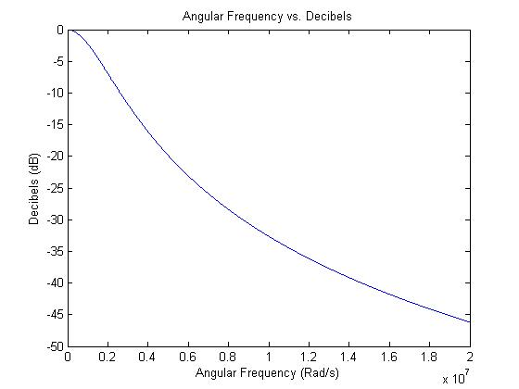

PART D

As the frequency goes up, ZC approaches zero and the gain approaches 1/ZR. This causes a short circuit because the voltage approaches zero.

PART E

As the frequency goes down, ZC approaches infinity and the gain approaches one. This causes an open circuit because the voltage reaches Vi, which in this case is 20 volts.

PART F

At about 0.7 gain, the frequency needs to be 5.694e7Hz. (1/RC) = 2e5hz, and this is a much lower number than needed to get 0.7 gain.

PART G

